St. George Serbian Orthodox Church
5830 Glenview Avenue
Cincinnati, OH 45224, USA

Very Reverend Petar Petrovic Divine Liturgy: 10:30 AM
Church: (513)542-4452 Feast Day Liturgy: 8:00 AM
Mobil: (513)544-7481 Confession: before Divine Liturgy
Email: blagoslov@cinci.rr.com Church School: 10:30 AM
Home page: www.stgeorgecinci.org

First Sunday of Great Lent – Sunday of Orthodoxy March 24, 2013

HOLY BREAD: Protinitza Gordana Petrovic READER: Adam Meador
LUNCH SPONSOR: Danica Vukosav
COLLECTION & USHERS: Men of St. George
ALTAR HELPERS: Zoran Zivadinovic

WELCOME! We would like to welcome our visitors with us today. We invite you to follow the Divine Liturgy, which begins on page 28 of the Blue Service Books. WE REGRET THAT THE DIVISION OF CHIRISTIANITY DOES NOT PERMIT US TO OFFER COMMUNION TO NON-ORTHODOX OR THOSE OF THE CHURCH WHO ARE UNPREPARED. However, please come forward at the end of the Divine Liturgy to venerate the Cross and receive the Antidoron - blessed bread - as a token of love and fellowship. PLEASE RESPECT THE HOLY LITURGY BY ARRIVING TO CHURCH ON TIME AND PARTAKING IN THE LITURGY TOGETHER WITH THE ENTIRE CONGREGATION. The prosperity of our Church is in your hands! Please remember to leave your contact information by signing the guest book before you leave the Church.

EPISTLE: (Hebrews 11:24-26, 32-12:2 ) By faith Moses, when he was come to years, refused to be called the son of Pharaoh's daughter; Choosing rather to suffer affliction with the people of God, than to enjoy the pleasures of sin for a season; Esteeming the reproach of Christ greater riches than the treasures in Egypt: for he had respect unto the recompence of the reward. And what shall I more say? for the time would fail me to tell of Gedeon, and of Barak, and of Samson, and of Jephthae; of David also, and Samuel, and of the prophets:Who through faith subdued kingdoms, wrought righteousness, obtained promises, stopped the mouths of lions. Quenched the violence of fire, escaped the edge of the sword, out of weakness were made strong, waxed valiant in fight, turned to flight the armies of the aliens. Women received their dead raised to life again: and others were tortured, not accepting deliverance; that they might obtain a better resurrection: And others had trial of cruel mockings and scourgings, yea, moreover of bonds and imprisonment: They were stoned, they were sawn asunder, were tempted, were slain with the sword: they wandered about in sheepskins and goatskins; being destitute, afflicted, tormented; (Of whom the world was not worthy:) they wandered in deserts, and in mountains, and in dens and caves of the earth. And these all, having obtained a good report through faith, received not the promise: God having provided some better thing for us, that they without us should not be made perfect.Wherefore seeing we also are compassed about with so great a cloud of witnesses, let us lay aside every weight, and the sin which doth so easily beset us, and let us run with patience the race that is set before us, Looking unto Jesus the author and finisher of our faith; who for the joy that was set before him endured the cross, despising the shame, and is set down at the right hand of the throne of God.

GOSPEL: (John 1:43-51) The day following Jesus would go forth into Galilee, and findeth Philip, and saith unto him, Follow me. Now Philip was of Bethsaida, the city of Andrew and Peter. Philip findeth Nathanael, and saith unto him, We have found him, of whom Moses in the law, and the prophets, did write, Jesus of Nazareth, the son of Joseph. And Nathanael said unto him, Can there any good thing come out of Nazareth? Philip saith unto him, Come and see. Jesus saw Nathanael coming to him, and saith of him, Behold an Israelite indeed, in whom is no guile! Nathanael saith unto him, Whence knowest thou me? Jesus answered and said unto him, Before that Philip called thee, when thou wast under the fig tree, I saw thee. Nathanael answered and saith unto him, Rabbi, thou art the Son of God; thou art the King of Israel. Jesus answered and said unto him, Because I said unto thee, I saw thee under the fig tree, believest thou? thou shalt see greater things than these. And he saith unto him, Verily, verily, I say unto you, Hereafter ye shall see heaven open, and the angels of God ascending and descending upon the Son of man.

REMEMBER IN YOUR PRAYERS

HEALTH OF: Geneva Jokich, Jennie Pjanich, Zora Droca, Spaso Droca, Heather Komnenovic, Ninko Stakic, Ranko Tepsic, Stacy, Ionel Dumitru, Irma Riordan, DEPARTED: +Stanisa Bojic. PRAY FOR THE CHRISTIANS THROUGHOUT THE WORLD

Pastoral Visitations: Ranko Tepsic
SUNDAY March 24 Sunday of Orthodoxy
Divine Liturgy 10:30 AM
Lunch Sponsor: Danica Vukosav
Church Board Meeting

SUNDAY March 31 Divine Liturgy 10:30 AM
Cake and Coffee: Jasmina Jovic and family

SUNDAY April 7 Divine Liturgy 10:30 AM
Vesper Service at 5:00PM
Father Isak Kisin from Columbus
After service, dinner will be served.
Please mark your calendars!

SUNDAY April 7 BAPTISM
Mason, son of Tony and Jennifer Vujic, and grandson of Ljubomir and Slavica, will be baptized. CONGRATULATIONS!!!

SATURDY April 27 Lazarus Saturday (Vrbica)
Vesper Service at 5:00 PM
Your participation on VRBICA is really necessary. On that day, children should be
together with their parents in Church. With
branches in our hands and song on our lips, we
will celebrate the “Glorious Entrance of our
Lord Jesus Christ into the City" of Jerusalem.

SYNODIKON FOR SUNDAY OF ORTHODOXY
As the Prophets saw, as the Apostles taught, as the Church has received, as the Teachers express in dogma, as the inhabited world understands together with them, as grace illumines, as the truth makes clear, as error has been banished, as wisdom makes bold to declare, as Christ has assured, so we think, so we speak, so we preach, honouring Christ our true God, and his Saints, in words, in writings, in thoughts, in sacrifices, in churches, in icons, worshipping and revering the One as God and Lord, and honouring them because of their common Lord as those who are close to him and serve him, and making to them relative veneration.
This is the faith of the Apostles; this is the faith of the Fathers; this is the faith of the Orthodox; this faith makes fast the inhabited world.

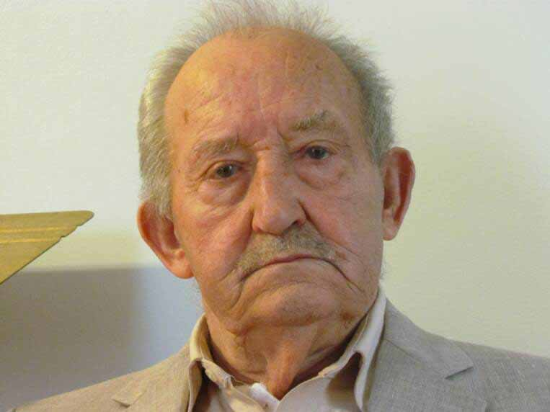
POMEN: In memory of +Stanisa Bojic - husband of Dusica, father of protinitza Gordana, father-in-law of Fr. Petar, grandfather of Dusan and Lidija Petrovic, and great-grandfather of Marko and Jovan Petrovic.
+Stanisa fell asleep in the Lord on March 18th, 2013. The funeral was conducted on March 19th, 2013 at our St. George Church. His remains are buried at the Serbian Monastery “New Gracanica” in Chicago, IL. Instead of sending cards, we are asking you to pray for his departed soul. If you wish, you can make a donation to St. George Church in his memory. MAY HIS MEMORY BE ETERANL!

+Remember the sick, the suffering, the imprisoned, those in rehabilitation centers, the homebound, the mentally ill, all of their caretakers and the institution staffs.

+Prepare for Holy Confession and Holy Communion on a regular basis.

+Every parishioner is a missionary for the St. George Church.

Sunday school in Session: If you are in Church with children, please take them to church hall for Sunday School.

St. George Serbian Orthodox Church

March 24, 2013

SUNDAY OF ORTHODOXY

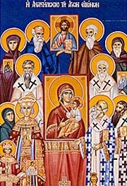
Reflection from a parishioner
As a child, growing up in the 60's and 70's... our focus during Great Lent was always on meals that did not include meat or dairy products. What could you cook that did not include either and would actually taste good? As a result, the default was always food that was very simple. Now that I am older, I have learned a little more about the Orthodox faith and what the Great Fast entails. We fast from animal products to show us that we are dependent upon God. In today's society, we have so many more options available that make Lenten meals even better. Many grocery stores carry vegan products, bakeries can create dairy free cakes, restaurants have vegan pulled pork sandwiches. What I remembered through this menu planning process is what a monk told me a few years ago...don't focus so much on the food but on your actions and what you do. I don't think I have ever received better advice. As I sat down and thought about my Lenten preparations, I also reflected on helping others...whether it is your brother, a homeless person, a baba who can't find a shopping cart in the grocery store or simply just a kind word in a time of need. Helping others is what Christ did, the Saints did and we are called to do. Let us remember that during this time of Great Lent, the Stewardship that we give to our Church is also used for the many ministries that provide this opportunity to help others.

Fill out the "STEWARDSHIP" form for 2013. Please give your time and talents!

