St. George Serbian Orthodox Church
5830 Glenview Avenue
Cincinnati, OH 45224, USA

Very Reverend Petar Petrovic Divine Liturgy: 10:30 AM
Church: (513)542-4452 Feast Day Liturgy: 8:00 AM
Mobil: (513)544-7481 Confession: before Divine Liturgy
Email: blagoslov@cinci.rr.com Church School: 10:30 AM
Home page: www.stgeorgecinci.org

Second Sunday of Great Lent March 31st, 2013

HOLY BREAD: Protinitza Gordana Petrovic READER: Adam Meador
CAKE AND COFFEE SPONSOR:Jasmina Jovic
COLLECTION & USHERS: Men of St. George
ALTAR HELPERS: Zoran Zivadinovic

WELCOME! We would like to welcome our visitors with us today. We invite you to follow the Divine Liturgy, which begins on page 28 of the Blue Service Books. WE REGRET THAT THE DIVISION OF CHIRISTIANITY DOES NOT PERMIT US TO OFFER COMMUNION TO NON-ORTHODOX OR THOSE OF THE CHURCH WHO ARE UNPREPARED. However, please come forward at the end of the Divine Liturgy to venerate the Cross and receive the Antidoron - blessed bread - as a token of love and fellowship. PLEASE RESPECT THE HOLY LITURGY BY ARRIVING TO CHURCH ON TIME AND PARTAKING IN THE LITURGY TOGETHER WITH THE ENTIRE CONGREGATION. The prosperity of our Church is in your hands! Please remember to leave your contact information by signing the guest book before you leave the Church.

EPISTLE: (Hebrews 1:10-2:3 ) And, Thou, Lord, in the beginning hast laid the foundation of the earth; and the heavens are the works of thine hands: They shall perish; but thou remainest; and they all shall wax old as doth a garment; And as a vesture shalt thou fold them up, and they shall be changed: but thou art the same, and thy years shall not fail. But to which of the angels said he at any time, Sit on my right hand, until I make thine enemies thy footstool? Are they not all ministering spirits, sent forth to minister for them who shall be heirs of salvation? Therefore we ought to give the more earnest heed to the things which we have heard, lest at any time we should let them slip.For if the word spoken by angels was stedfast, and every transgression and disobedience received a just recompence of reward; How shall we escape, if we neglect so great salvation; which at the first began to be spoken by the Lord, and was confirmed unto us by them that heard him;
GOSPEL: (Mark 2:1-12 ) 1 And again he entered into Capernaum after some days; and it was noised that he was in the house. And straightway many were gathered together, insomuch that there was no room to receive them, no, not so much as about the door: and he preached the word unto them. And they come unto him, bringing one sick of the palsy, which was borne of four. And when they could not come nigh unto him for the press, they uncovered the roof where he was: and when they had broken it up, they let down the bed wherein the sick of the palsy lay. When Jesus saw their faith, he said unto the sick of the palsy, Son, thy sins be forgiven thee. But there was certain of the scribes sitting there, and reasoning in their hearts, Why doth this man thus speak blasphemies? who can forgive sins but God only? And immediately when Jesus perceived in his spirit that they so reasoned within themselves, he said unto them, Why reason ye these things in your hearts? Whether is it easier to say to the sick of the palsy, Thy sins be forgiven thee; or to say, Arise, and take up thy bed, and walk? But that ye may know that the Son of man hath power on earth to forgive sins, (he saith to the sick of the palsy,) I say unto thee, Arise, and take up thy bed, and go thy way into thine house. And immediately he arose, took up the bed, and went forth before them all; insomuch that they were all amazed, and glorified God, saying, We never saw it on this fashion.
REMEMBER IN YOUR PRAYERS

HEALTH OF: Geneva Jokich, Jennie Pjanich, Zora Droca, Spaso Droca, Heather Komnenovic, Ninko Stakic, Ranko Tepsic, Stacy, Ionel Dumitru, Irma Riordan, DEPARTED: +Stanisa Bojic, +Ruzica Jovanovic;

PRAY FOR THE CHRISTIANS THROUGHOUT THE WORLD

Pastoral Visitations: Ranko Tepsic;
SUNDAY March 31 Divine Liturgy 10:30 AM
Cake and Coffee: Jasmina Jovic and family

SUNDAY April 7 Divine Liturgy 10:30 AM

SUNDAY April 7 Vesper Service at 5:00PM
Father Isak Kisin from Columbus
After service, dinner will be served.
Please mark your calendars!

SUNDAY April 7 BAPTISM
Mason, son of Tony and Jennifer Vujic, and grandson of Ljubomir and Slavica, will be baptized. CONGRATULATIONS!!!

SATURDY April 27 Lazarus Saturday (Vrbica)
Vesper Service at 5:00 PM
Your participation on VRBICA is really necessary. On that day, children should be
together with their parents in Church. With
branches in our hands and song on our lips, we
will celebrate the “Glorious Entrance of our
Lord Jesus Christ into the City" of Jerusalem.

SAINT CYRIL, ARCHBISHOP OF JERUSALEM
Cyril was born in Jerusalem during the reign of Constantine the Great and died during the reign of Theodosius the Great [315-386 A.D.] He was ordained a priest in 346 A.D. and succeeded to the throne of Blessed Maximus, Patriarch of Jerusalem in 350 A.D. On three occasions he was dethroned and banished into exile until finally, during the reign of Theodosius, he was restored and lived peacefully for eight years and then gave up his soul to the Lord. He underwent two difficult struggles: one, against the Arians, who became powerful under Constantius, the son of Constantine, and the other during the reign of Julian the Apostate [this turncoat] and with the Jews. At the time of the dominance of the Arians and on the Day of Pentecost, a sign of the cross, brighter than the sun, appeared which stretched over Jerusalem and the Mount of Olives and lasted for several hours from the ninth hour in the morning. Concerning this phenomenon, seen by all the inhabitants of Jerusalem, a report was written to Emperor Constantius which served much in establishing Orthodoxy against the heretics. During the time of the Apostate, still another sign occurred. In order to humiliate the Christians Julian persuaded the Jews to restore the Temple of Solomon. Cyril prayed to God that this not happen. There was a terrible earthquake which destroyed all that had been newly built. Then the Jews began restoration anew. Again, there was an earthquake which destroyed not only the newly constructed portion but overturned and scattered the old stones beneath the ground which supported the Temple. And so the words of the Lord came true that "there will not be left here a stone upon another stone that will not be thrown down" (St. Matthew 13:2 - St. Luke 2:6). Among the many writings of this holy father is his Catechetical Discourses, a first class work preserved to the present which confirms the faith and practice of Orthodoxy. This saint was a unique arch-pastor and a great ascetic. He was meek and humble, exhausted from fasting, and pallid. After a life of many labors and noble struggles for the Orthodox Faith, Cyril peacefully died and took up habitation in the eternal court of the Lord.
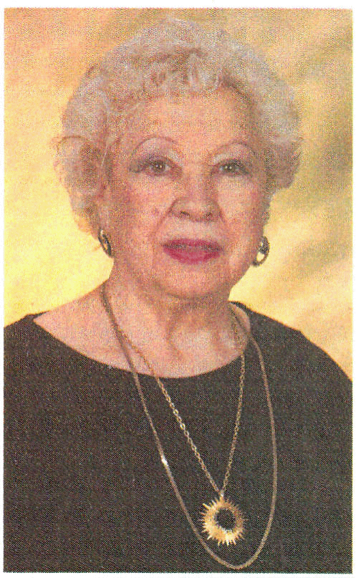
POMEN: Pomen was offered in loving memory of +Ruzica Jovanovic. She Entered into life on July 2, 1928 in Serbia. Entered Eternal Life, March 13, 2013 Louisville, Kentucky.Pomen was offered by niece Biljana Monsky with family. +Ruzica was helping our St.George Church financially for many years. May her memory be eternal.

+Ruzica Jovanovic

+Remember the sick, the suffering, the imprisoned, those in rehabilitation centers, the homebound, the mentally ill, all of their caretakers and the institution staffs.

+Prepare for Holy Confession and Holy Communion on a regular basis.

+Every parishioner is a missionary for the St. George Church.

St. George Serbian Orthodox Church

WEEKLY BULLETIN

March 31, 2013

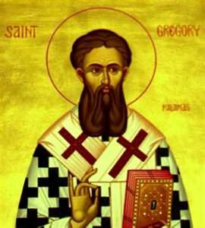
Today is the second Sunday of Great Lent, which commemorates St. Gregory Palamas. The Epistle reading for today is Hebrews 1:10-2:3
10 He also says, "In the beginning, Lord, you laid the foundations of the earth, and the heavens are the work of your hands. 11 They will perish, but you remain; they will all wear out like a garment. 12You will roll them up like a robe; like a garment they will be changed. But you remain the same, and your years will never end." 13To which of the angels did God ever say, "Sit at my right hand until I make your enemies a footstool for your feet" 14 Are not all angels ministering spirits sent to serve those who will inherit salvation? 1We must pay the most careful attention, therefore, to what we have heard, so that we do not drift away. 2 For since the message spoken through angels was binding, and every violation and disobedience received its just punishment, 3 how shall we escape if we ignore so great a salvation? This salvation, which was first announced by the Lord, was confirmed to us by those who heard him.
There are several themes found within these verses... St. Dorotheos of Gaza says "who will give us back this present time if we waste it?"
1 Corinthians 2:9 says "But as it is written, Eye hath not seen, nor ear heard, neither have entered into the heart of man, the things which God hath prepared for them that love him."
In order to see what God has prepared for us, we must work towards our salvation and do what is necessary to enter the eternal Kingdom. God will judge us by our works. To fit into Heaven, we must be prepared during this life here on earth - in our daily existence, body, soul and spirit and this requires a change... a change that is the primary focus of the period of Great Lent.
St. John Chrysostom says, "after our time on earth, there are no more opportunities for change so this leaves our life on earth as the only time during which change is possible."
· Change, with our focus on Church
· Change, with how we interact with people
· Change, with all of those bad habits we have
· Change, with the Stewardship of our Time, Talents and Treasures
This change is necessary for our salvation, for we know that God will judge us by our works, we just don't know when! We pray that this time of Great Lent provides you with the opportunity for reflection and the contemplation of change in your life.

Fill out the "STEWARDSHIP" form for 2013. Please give your time and talents!

