St. George Serbian Orthodox Church
5830 Glenview Avenue
Cincinnati, OH 45224, USA

Very Reverend Petar Petrovic Divine Liturgy: 10:30 AM
Church: (513)542-4452 Feast Day Liturgy: 8:00 AM
Mobil: (513)544-7481 Confession: before Divine Liturgy
Email: blagoslov@cinci.rr.com Church School: 10:30 AM
Home Page: www.stgeorgecinci.org

Sunday of the Meatfare March 10, 2013

HOLY BREAD: Protinitza Gordana Petrovic READER: Men of St. George
LUNCH SPONSORS: Vidovic, Fisic, and Gajic Families
COLLECTION & USHERS: Men of St. George
ALTAR BOYS: All Available

WELCOME: We would like to welcome our visitors with us today. We invite you to follow the Divine Liturgy, which begins on page 28 of the Blue Service Books. WE REGRET THAT THE DIVISION OF CHIRISTIANITY DOES NOT PERMIT US TO OFFER COMMUNION TO NON-ORTHODOX OR THOSE OF THE CHURCH WHO ARE UNPREPARED. However, please come forward at the end of the Divine Liturgy to venerate the Cross and receive the Antidoron - blessed bread - as a token of love and fellowship. PLEASE RESPECT THE HOLY LITURGY BY ARRIVING TO CHURCH ON TIME AND PARTAKING IN THE LITURGY TOGETHER WITH THE ENTIRE CONGREGATION. The prosperity of our Church is in your hands! Please remember to leave your contact information by signing the guest book before you leave the Church.

EPISTLE: (I Cor. 8:8 - 9:2) But meat commendeth us not to God: for neither, if we eat, are we the better; neither, if we eat not, are we the worse.But take heed lest by any means this liberty of your's become a stumbling block to them that are weak. For if any man see thee which hast knowledge sit at meat in the idol's temple, shall not the conscience of him which is weak be emboldened to eat those things which are offered to idols; And through thy knowledge shall the weak brother perish, for whom Christ died? But when ye sin so against the brethren, and wound their weak conscience, ye sin against Christ. Wherefore, if meat make my brother to offend, I will eat no flesh while the world standeth, lest I make my brother to offend. Am I am not an apostle? am I not free? have I not seen Jesus Christ our Lord? are not ye my work in the Lord? If I be not an apostle unto others, yet doubtless I am to you: for the seal of mine apostleship are ye in the Lord.

GOSPEL: (Matt: 25:31-46) When the Son of man shall come in his glory, and all the holy angels with him, then shall he sit upon the throne of his glory: And before him shall be gathered all nations: and he shall separate them one from another, as a shepherd divideth his sheep from the goats: And he shall set the sheep on his right hand, but the goats on the left. Then shall the King say unto them on his right hand, Come, ye blessed of my Father, inherit the kingdom prepared for you from the foundation of the world: For I was an hungred, and ye gave me meat: I was thirsty, and ye gave me drink: I was a stranger, and ye took me in: Naked, and ye clothed me: I was sick, and ye visited me: I was in prison, and ye came unto me. Then shall the righteous answer him, saying, Lord, when saw we thee an hungred, and fed thee? or thirsty, and gave thee drink? When saw we thee a stranger, and took thee in? or naked, and clothed thee? Or when saw we thee sick, or in prison, and came unto thee?
And the King shall answer and say unto them, Verily I say unto you, Inasmuch as ye have done it unto one of the least of these my brethren, ye have done it unto me. Then shall he say also unto them on the left hand, Depart from me, ye cursed, into everlasting fire, prepared for the devil and his angels: For I was an hungred, and ye gave me no meat: I was thirsty, and ye gave me no drink: I was a stranger, and ye took me not in: naked, and ye clothed me not: sick, and in prison, and ye visited me not. Then shall they also answer him, saying, Lord, when saw we thee an hungred, or athirst, or a stranger, or naked, or sick, or in prison, and did not minister unto thee? Then shall he answer them, saying, Verily I say unto you, Inasmuch as ye did it not to one of the least of these, ye did it not to me. And these shall go away into everlasting punishment: but the righteous into life eternal.

REMEMBER IN YOUR PRAYERS

HEALTH OF: Geneva Jokich, Jennie Pjanich, Zora Droca, Spaso Droca, Heather Komnenovic, Ninko Stakic, Ranko Tepsic, Stacy, Ionel Dumitru, Irma Riordan, Stanisa Bojic, Dusica Bojic DEPARTED: Helmut Kowatsch PRAY FOR THE CHRISTIANS THROUGHOUT THE WORLD
SATURDAY March 9 A one year memorial service was offered IMO of +Milos Dimitric by his wife Slobodanka and daughter Svetlana (Ceca) Tripunovic with Family. May his memory be eternal!

SUNDAY March 10 Divine Liturgy 10:30 AM
One year memorial service IMO +Aleksa Gajic

SUNDAY March 17 Divine Liturgy 10:30 AM
Cake and Coffee Sponsor:Milena Davenport

MONDAY March 18 LENT BEGINS
SUNDAY March 24 Sunday of Orthodoxy
Divine Liturgy 10:30 AM
Lunch Sponsor: Danica Vukosav
SUNDAY March 31 Divine Liturgy 10:30 AM
Cake and Coffee: Sponsor needed

SUNDAY April 7 Vesper Service at 5:00PM
Father Isak Kisin from Columbus
After service, dinner will be served.
Please mark your calendars!

Saint Tarasius Archbishop: His predecessor, Patriarch Paul secretly, relinquished the throne, entered a monastery and received the Schema [The Great Angelic Habit]. Irene and Constantine reigned at the time. By Paul's counsel, Tarasius, a senator and royal advisor, was chosen as patriarch in the year 783 A.D. He was quickly elevated through the ecclesiastical ranks and became patriarch. A man of great learning and great zeal in the Orthodox Faith, Tarasius accepted this rank reluctantly in order to assist Orthodoxy in the struggle against heresies, especially against Iconoclasm. During his tenure, the Seventh Ecumenical Council [Nicaea, 783 A.D.} was convened, where Iconoclasm was condemned and the veneration of holy icons was confirmed and restored. Tarasius was very charitable toward orphans and the poor, creating for them shelters and distributed food to them. Toward the powerful, Tarasius was decisive in his defense of faith and morals. When Emperor Constantine banished Maria, his lawful wife and took a kinswoman and lived with her, and sought a blessing for marriage from the patriarch, Tarasius not only refused him a blessing, but first counseled him, after that reproached him, and finally forbid him to receive Holy Communion. Before his death, many saw how Tarasius replied to the demons saying: "I am not guilty of this sin! I am not guilty either of that sin!" Until his weakened tongue could not longer speak, he then began to defend himself with his hands driving away the demons. When he expired, his face lightened up as the sun. This truly great hierarch died in the year 806 A.D. He governed the Church for twenty-two years and four months.
Pastoral Visitations: Ranko Tepsic
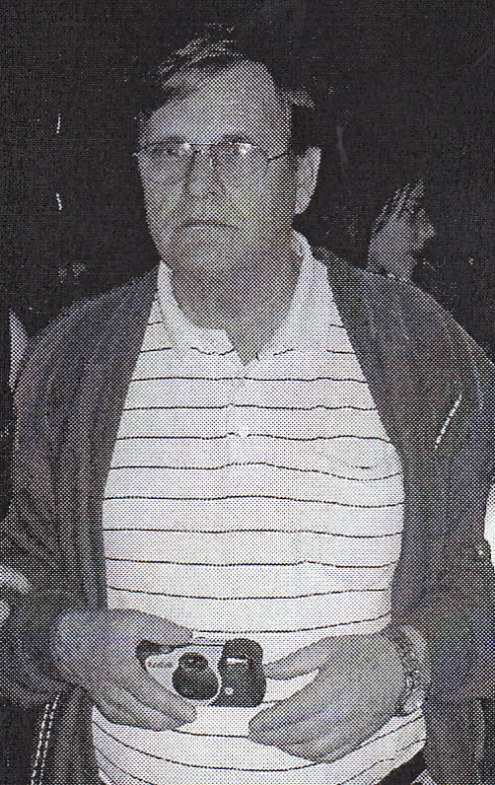
One Year Memorial Service (Parastos): in memory of +Aleksa Gajic, offered by his wife Gordana Gajic, Zdravko Vidovic & family, & Igor Fisic & family. May his memory be eternal! After the memorial service, all are invited in the church hall for a memorial lunch.

Remember in Prayer: +Helmut Kowatsch, father of Stefan and father-in-law of Adriana Kowatsch. +Helmut died on March 1st, 2013. May his memory be eternal!

Sponsors for Monthly Bulletin: Thank you to all of our parishioners for sponsoring our “Monthly Bulletin” for 2013.

Making up visit: The central sign of our acceptance of God’s sanctification of creation at Holy Theophany is the blessing of our homes. This is done: 1) to reveal the home as to what it is created by God to be, which is a way to heaven 2) to rid the home of every evil 3) to reveal the truth that family is a small Church unit in Christ 4) to consecrate the home and all the activity in it to God 5) to fill the home and those who abide in it with God’s grace and blessings.

Easter Lunch Sponsor: If you would like to be a sponsor for our Easter luncheon, please call the Church Office at (513)542-4452 or e-mail Fr. Petar at blagoslov@cinci.rr.com.

St. George Serbian Orthodox Church
March 10, 2013

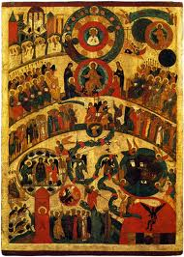

Stewardship Reflection

Today is Meatfare Sunday, also referred to as the Sunday of the Last Judgment. The Gospel reading for today provides us with many examples where Christ has illustrated that when our brothers and sisters are in need and we fail or refuse to help them, we are failing and refusing to help Christ. "Inasmuch as you did not do it to one of the least of these, you did not do it to Me."
St. John Chrysostom in his Homily LXXIX on Matthew 25 says, "And in return for what do they receive such things? For the covering of a roof, for a garment, for bread, for cold water, for visiting, for going into the prison. For indeed in every case it is for what is needed; and sometimes not even for that. For surely, as I have said, the sick and he that is in bonds seeks not for this only, but the one to be loosed, the other to be delivered from his infirmity. But He, being gracious, requires only what is within our power, or rather even less than what is within our power, leaving to us to exert our generosity in doing more."
God asks us to provide for our Church through the Stewardship of Time, Talents and Treasures but God also reminds us that to be gracious "requires only what is within our power" - we must give freely from our heart, unconditionally and in any way that we can to help our Church, those in need and the many ministries that our parish provides.

Fill out the "STEWARDSHIP" form for 2013. Give your time and talents.

